Cultural Exchange and Education: The Calapan Museum's Role in Promoting Art and History

An
Application Development Project
Presented to the Faculty of
Mindoro State University Calapan City Campus
Masipit, Calapan City
Oriental Mindoro

In Partial Fulfillment
of the Requirements for the Degree
Bachelor of Science in Information Technology

by:
Espina, Lance Cedrick F.
Maranan, Glesie F.
Ortega Christ John P.

November 26, 2024

TABLE OF CONTENTS
Title page
Table of Contents
I: INTRODUCTION
Project Context
Objectives
Scope and Limitations
Definition of Terms
II: REQUIREMENTS SPECIFICATIONS
Hardware and Software Requirements
Functional Requirements
Non-Functional Requirements
Operational Requirements
Performance Requirements
Security Requirements
III: DESIGN AND DEVELOPMENT METHODOLOGIES
System Design
Database Design
Architectural Diagram/Block Diagram
DFD Level 0
UML Use-Case Diagram
Sample Mockup
Methodology
IV: DEVELOPMENT, TESTING AND EVALUATION RESULT

Presentation of the System Output
Testing Results

ISO 25010 Evaluation Result
V: DESIGN AND DEVELOPMENT METHODOLOGIES
Conclusion
Recommendation

LIST OF TABLES

Table 1: Software Requirements

LIST OF FIGURES
Figure 1: Database Design
Figure 2: System Architectural Design of Cultural Exchange and Education: The Calapan Museum's Role in Promoting Art and History
Figure 3: Data Flow of the Proposed System
Figure 4: Museum Use Case Diagram
Figure 5.: Sample Mockup
Figure 6: Agile Method

LIST OF APPENDICES

CHAPTER I
INTRODUCTION
PROJECT CONTEXT
As museums increasingly embrace digital transformation, offering an engaging and accessible online presence is critical for enhancing public interaction with cultural heritage. The Oriental Mindoro Heritage Museum faces the challenge of making its rich cultural assets accessible beyond its physical location in Calapan. Like many cultural institutions, the museum seeks to preserve and promote local heritage through both physical exhibits and digital platforms. Without an integrated online system, museum content remains geographically restricted, limiting the museum’s ability to engage a broader audience. The growing trend of museums adopting digital tools underscores the importance of expanding access to collections and educational materials.
The Oriental Mindoro Heritage Museum Digital Platform is designed to address these challenges by offering an immersive, user-friendly web application. It will feature multimedia resources such as cultural articles, galleries, event announcements, and interactive educational activities to create a dynamic online museum experience. This approach aligns with best practices in the museum sector, where integrating digital tools is increasingly seen as crucial to engaging younger, tech-savvy audiences (Capriotti, 2011). By offering a comprehensive platform, the museum will not only make its content more accessible but also enhance user engagement through features like personalized dashboards and cultural quizzes.
This project reflects findings from recent studies that highlight the importance of digital transformation in museums to preserve cultural heritage and improve user engagement (Jones, 2015). The platform will allow local and international users to explore exhibits remotely, aligning with the museum's mission to educate the public about Oriental Mindoro's history and culture. As noted by Chen et al. (2023), leveraging technology can significantly improve institutional outreach and audience engagement, making digital platforms an essential component of modern museum strategies.
The platform will support various user roles, including visitors, museum staff, and researchers. Users will have the ability to register, manage their profiles, and engage with museum content through a seamless interface. Museum administrators will be equipped with content management tools that allow them to publish articles, galleries, and event information easily. This level of functionality mirrors modern content management systems (CMS) used by leading institutions to streamline digital content creation and management (Sharma & Patel, 2022).

Additionally, interactive features such as Visit Booking will streamline the process of scheduling visits, providing users with real-time availability, and booking options. Removing the barriers between digital engagement and in-person experiences ensures a smoother transition for visitors, enhancing both digital and physical museum attendance. Studies have shown that online booking systems improve user convenience and promote increased participation in museum activities (Thompson & Wright, 2023).
Overall, the Oriental Mindoro Heritage Museum Digital Platform not only contributes to cultural preservation but also addresses modern demands for accessibility and engagement through digital innovation.

OBJECTIVES
General Objective:
The main objective of this study is to design and develop an interactive, user-friendly web-based platform for the Oriental Mindoro Heritage Museum that promotes cultural heritage and historical knowledge by providing accessible digital resources, interactive educational activities, and user engagement features to a broader audience specific objective aims to:

- To develop a multimedia content management system that allows museum administrators to create, edit, and publish cultural articles, galleries, and event announcements, ensuring that content is easily accessible to users.

- To implement a user registration and management system that enables users to create accounts, manage profiles, and interact with museum content, such as saving articles or booking visits, enhancing personalized user engagement.

- To design an interactive visit booking system that provides real-time availability for scheduling museum visits, offering users a convenient way to book and manage their visits online.

- To integrate interactive educational tools such as cultural quizzes and trivia, which aim to engage users in learning about Oriental Mindoro’s cultural history and heritage in a fun and informative manner.

- To ensure multilingual support across the platform allowing users to access content in various languages, including Filipino, English, and local dialects, for a more inclusive and diverse audience.

- To enhance social media integration allowing users to share cultural articles, images, and event updates, thereby extending the museum's reach, and encouraging community engagement.

- To develop a secure and scalable platform with robust user authentication, role-based access control, and data encryption, ensuring the protection of user information and digital content while supporting future expansions.

- To provide analytical tools for museum staff enabling them to track user engagement, monitor trends in content interaction, and gather insights for improving the museum’s digital strategies and offerings.

- To implement a feedback and rating system that allows users to provide feedback on their experiences with the platform, museum content, and exhibits, which will help museum staff continuously improve user satisfaction and platform usability.

- To ensure mobile responsiveness and cross-browser compatibility enabling users to access the platform seamlessly from different devices and browsers, ensuring consistent user experience regardless of their device or operating system.

- To facilitate content moderation and community engagement here museum staff can review user comments and discussions on articles and cultural content, ensuring respectful interaction while promoting meaningful conversations.

- To develop a personalized user dashboard where registered users can manage their activity, including viewing past and upcoming visits, saving favorite exhibits, and receiving notifications for upcoming events and new content.

- To integrate high-resolution image galleries and multimedia content offering users immersive experience as they explore exhibits, artifacts, and museum collections through visually rich content.

- To ensure secure data storage and regular backups safeguarding user information, cultural content, and multimedia assets, while maintaining the integrity and availability of the platform.

SCOPE AND LIMITATIONS
The scope of this study focuses on developing an interactive digital platform for the Oriental Mindoro Heritage Museum, aimed at enhancing user engagement with the region's cultural and historical resources. The platform will cater to diverse user roles, offering tailored access to blog articles, multimedia galleries, educational activities, and event bookings. It will include a content management system for museum staff to manage content and user interactions, as well as analytics tools for tracking engagement. However, the study faces several limitations, including the need for stable internet access, potential digital literacy barriers, and delays in content moderation. The platform's content will focus primarily on Oriental Mindoro's cultural heritage, limiting its coverage of broader cultural topics. Device compatibility and resource constraints may also hinder user experience and the timely implementation of updates, while low user engagement could impact the platform's success in fostering community participation.

DEFINITION OF TERMS

- Cultural Heritage: The collection of artifacts, traditions, and monuments that reflect the history and identity of a community.

- Role-Based Access Control (RBAC): A security model that assigns access rights based on user roles to manage permissions effectively.

- Analytics and Reporting: The analysis of user data to track engagement, submission trends, and performance metrics.

- Scalability: The platform's ability to grow and accommodate future enhancements without compromising performance.

- User Engagement: The interaction and involvement of users with the platform’s content and features, measured through various metrics.

- Content Management System (CMS): A backend system that enables administrators to create, edit, and publish content on the platform.

- Cultural Education: Teaching users about the history, art, and heritage of Calapan and Oriental Mindoro through interactive content.

- User Profile Management: A feature that allows users to manage their personal information, preferences, and interaction history within the platform.

CHAPTER II
REQUIREMENTS SPECIFICATION

HARDWARE AND SOFTWARE REQUIREMENTS
Component | Minimum Requirement | Recommend Requirement
Operating System | Windows 10 | Windows 11
Processor | 2.0 GHz Dual Core –  3.0 GHz Quad – Core | 3.0 GHz quad-core
Ram | 4 GB RAM | 8 GB RAM
Storage | 30 GB Available Disk Space | 50 GB Available Disk Space
Web Server |  | Apache 2.4
Database | MYSQL 8.0 - Laragon – Firewall | MYSQL 8.0
Frontend Framework | Vue.js | Vue.js
Browser Support | Chrome, Firefox, Edge | Chrome, Firefox, Edge
Network | Broadband internet connection (5 Mbps or higher) | High-speed broadband internet connection (10 Mbps or higher)

Table 1: Software Requirements
The software components play a vital role in data processing, communication, and user interaction. The following software will be utilized:
- Programming and Development Tools
- Backend Framework: Node.js (for server-side logic and API development)
- Frontend Framework: Vue.js (for building the user interface)
- Web Framework: Express.js (for handling routing and middleware on the backend)
- Database: MySQL or MongoDB or Firewall (for managing data storage)

FUNCTIONAL REQUIREMENTS
1. User Registration and Profile Management
- Description: User can create account, verify email address, log in, manage their profile.
- Key Features:
- Registration with email verification.
- Profile management, allowing to user information (no bio field).
- Option to save favorite artifacts, painting, etc.
- Ticketing booking history and ability to leave reviews on the museum (no exhibit review).
- Importance: Personalization and easy access to profile information encourage repeat visits and engagement.

2. Event Management
- Description: Admins can manage museum events, and gallery.
- Key Features:
- Admin dashboard to create, edit, or delete events, and gallery items.
- Categorization for different gallery types (e.g., art, history, science).
- Importance: Facilitates effective management of museum activities, and gallery items.

3.Feedback System
  - Description: Users can review the system on galleries or events to share their experiences.
  - Key Features:
- Review and rating system for user feedback.
- Admin moderation tools for monitoring and responding to reviews.
  - Importance: Increases engagement and provides feedback for improving museum offerings.

4.Visit Booking System
  - Description: Allows users to book museum visits in advance.
  - Key Features:
- Real-time booking with availability for specific dates and times.

- Option to modify or cancel bookings through the user dashboard.
  - Importance: Offers convenience in planning visits, improving museum visitor management.

5.Online Museum Viewing
- Description: Allows users to explore galleries, and related information online
- Key Features:
- Multimedia and detailed descriptions of key galleries, artifacts, paintings, etc.

o Importance: Expands the museum’s reach, allowing remote users to engage with museum content.

6. Multimedia Integration
  - Description: Support for integrating rich media, events, and galleries.
  - Key Features:
- Uploading and embedding images, and files.
- Image galleries for artifacts and other collections
- Importance: Adds multimedia depth to the museum's online presence.

7. Search Integration
- Description: Tools for users to easily find items in collection, favorite collections. Tools for admin to easily find Event and Gallery Items.
- Key Features:
- Search bar with keyword search.
- Importance: Enhances usability by making content discovery easier

and more tailored.

8.180-Degree Virtual Tour of Museum Interior and
  - Description: The platform offers virtual tours of the museum's interior.
  - Key Features:
- Users can interact through different areas of the museum, including the main hall, corridors, and special sections.
  - Importance: Provides an immersive experience, allowing users to explore the museum’s ambiance remotely.

NON-FUNCTIONAL
- Usability
  - Description: The platform should be intuitive and visually appealing.
  - Specific Features:
    - Consistent design elements and branding.
    - Clear navigation menus and user prompts.
    - Accessible design for users with disabilities.
  - Importance: A user-friendly interface increases user satisfaction and retention.
- Performance
  - Description: The blog should load quickly and efficiently.
  - Specific Features:
    - Optimized image and video sizes to reduce loading times.
    - Use of caching mechanisms for faster access to frequently visited content.
    - Performance testing under various conditions to ensure stability.
  - Importance: Fast performance enhances user experience, especially for
  - multimedia-rich content.
- Security
  - Description: Protects user data and prevents unauthorized access.
  - Specific Features:
    - SSL encryption for secure data transmission.
    - Regular security audits and updates to plugins.
    - User authentication measures (e.g., two-factor authentication).
  - Importance: A secure platform fosters trust among users, encouraging them to engage more actively.
- Mobile Responsiveness
  - Description: The blog should be easily accessible on various devices.
  - Specific Features:
    - Responsive design that adjusts layout based on screen size.
    - Touch-friendly navigation for mobile users.
    - Testing on various devices and browsers for compatibility.
  - Importance: Mobile accessibility is crucial for reaching a broader audience in today’s digital landscape.
- SEO Optimization
  - Description: Enhance visibility in search engine results.
  - Specific Features:
    - Use of meta tags, alt attributes for images, and keyword-rich content.

    - Structured data markup to improve content indexing.
    - Analytics tools to track traffic and user behavior.
  - Importance: Improved SEO leads to greater visibility, attracting both local visitors and tourists.

Chapter III
Design and Development Methodologies

System Design
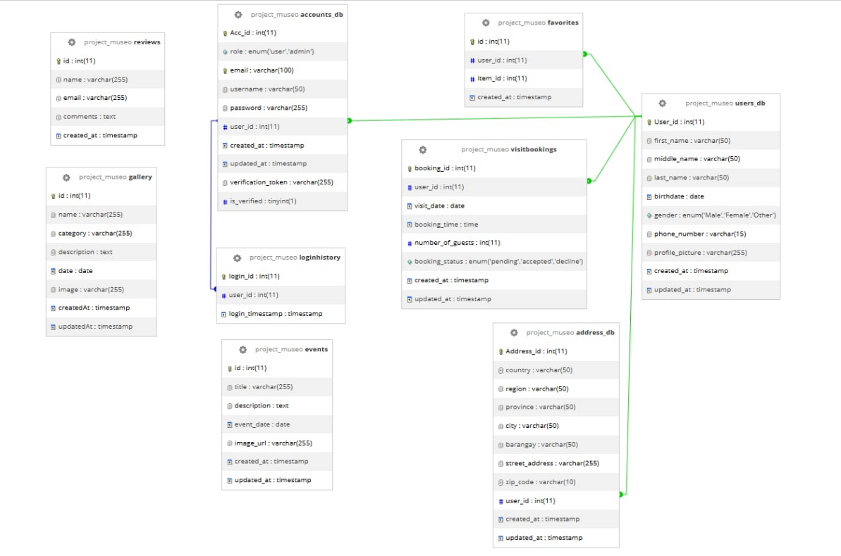
Database Design
Figure 1 illustrates the database schema for a digital platform designed for Cultural Exchange and Education: The Calapan Museum's Role in Promoting Art and History. The schema includes tables such as accounts_db for user credentials (email, password, etc.), users_db for detailed user profiles (name, gender, address), and gallery for storing multimedia items like images or videos associated with the museum's exhibits. It also includes tables for tracking visit bookings (visitbookings), museum events (events), and favorites (favorites), which allow users to interact with content. Address information is stored in the address_db table, while the loginhistory table monitors user access to the platform. These interconnected tables ensure a smooth user experience, from registration and visit scheduling to engagement with museum content and event participation.

Figure 1. Database Design

Each of these fields is part of the account_db table, which helps manage user account and ensure proper authentication and authorization it the platform.
Field Name | Data type | Size | Default | Description
Acc_id | Int | 11 | None | This the unique identifier to each account. It is an integer field that store the account’s ID in the database
role | enum(‘user’,’admin’) |  | User | This field specific the role of the account, either ‘user’ or ‘admin’. The default value is ‘user’, which indicates a regular user, while ‘admin’ refers to an administrative user with elevated privileges.
email | Varchar | 100 | Null | This stores the email address associated with the account. It is a variable character field with maximum length of 100 character, and it can be null if the email is not provided.
username | Varchar | 50 | Null | This is username associated with account. It is a variable character field with the length of 50 character, and it can be null if the username is not provided.
password | Varchar | 255 | Null | This field stores the password for the account. It can hold  up to 255 characters and is typically encrypted to ensure security. It can be null if no password is set.
user_id | Int | 11 | Null | This field links the account to a specific user by storing the user’s ID. It is an integer field, and its value can be null if no user is associated yet.
created_at | timestamp |  | current_timestamp() | This timestamp field automatically records the creation time of the account. It is set to the current timestamp by default when the account is created.
updated_at | timestamp |  | current_timestamp() | This timestamp field automatically records the last time the account was updated. It is also set to the current timestamp by default, reflecting when any modifications were made to the account.
verification_  token | Varchar | 255 | Null | This field stores a verification token, which is typically used for email verification or password reset  processes. It can hold up to 255 characters and can be null if not in use.
is_verified | Tinyint | 1 | 0 | This is a boolean field represented as a tiny integer, where a value of 0 means the account is not  verified, and a value of 1 means the account has been verified.
Table 2: Account
This table is essential for storing and managing address details linked to users, ensuring the proper organization of geographic information within the platform.
Field Name | Data type | Size | Default | Description
Address_id | Int | 11 | None | A unique identifier for each address entry in the table. It serves as the primary key for the table.
country | Vachar | 50 | Null | Stores the name of the country associated with the address. This is a variable character field with a maximum length of 50 characters. It can be null if the country information is not provided.
region | Vachar | 50 | Null | Stores the  name of the  region (e.g., state or district) for the address. This is a variable character field with a maximum length of  50 characters and can be null.
province | Vachar | 50 | Null | Stores the name of the province associated with the address. It has a maximum length of 50 characters and can be null.
city | Varchar | 50 | Null | Stores the name of the city for the address. It is a variable character field with a maximum length of 50 characters and can be null.
barangay | Vachar | 50 | Null | Stores the name of the barangay (local administrative district) associated with the address. It has a maximum  length of 50 characters and can be null.
street_address | Varchar | 255 | Null | Stores the detailed street address. It is a variable character field with a maximum length of 255 characters and can be null if the detailed street address is not provided
zip_code | Vachar | 10 | Null | Stores the postal or zip code for the address. This field has a maximum length of 10  characters and can be null.
user_id | Int | 11 | Null | Links the address to a specific user by storing the user's unique identifier (foreign key). It can be null if no user is associated with the address.
created_at | timestamp |  | current_timestamp() | Automatically stores the timestamp when the address entry is created. It is set to the current  timestamp by default.
updated_at | timestamp |  | current_timestamp() | Automatically stores the  timestamp when the address entry is last updated. It is also set to the current timestamp by default, reflecting the most recent modification to the entry.
` Table 3: Address Details
Field Name | Data type | Size | Default | Description
Id | Int | 11 | None | A unique identifier for each event entry in the table. It serves as the primary key, ensuring that each record is distinct.
title | Varchar | 255 | None | Stores the title or name of the event. This field has a maximum length of 255 characters and  is required (cannot be null).
description | Text |  | Null | Provides a detailed description or additional information about the event. This field can hold lengthy text and is optional (can be null).
event_date | Date |  | None | Records the date of the event. This field ensures that each event is linked to a specific calendar date and is mandatory.
image_url | Varchar | 255 | Null | Stores the URL or file path for an image associated with the event. This field has a maximum length of 255 characters and is optional (can be null).
created_at | Tmestamp |  | current_timestamp() | Automatically stores the timestamp when the event entry is created. It is set to the current timestamp by default, capturing the record's creation date and time.
updated_at | Tmestamp |  | current_timestamp() | Automatically stores the timestamp when the event entry is last updated. It is also set to the current timestamp by default, reflecting  the most recent modification to the record.

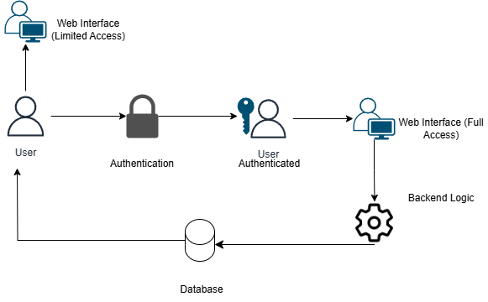
Architectural Diagram / Block Diagram
Figure 2. System Architectural Design of Cultural Exchange and Education: The Calapan Museum's Role in Promoting Art and History

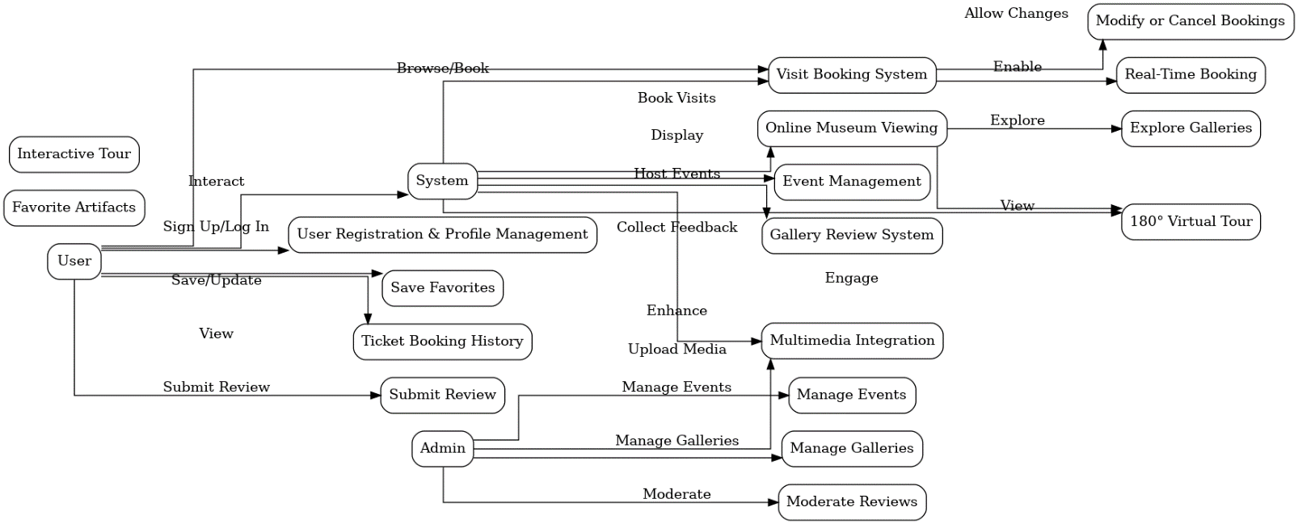
DFD Level 0
Figure 3: Data Flow of the Proposed System

UML Use-case Diagram
Figure 4 shows the flow of the process within the museum management system. This diagram represents the interaction between users and administrators with the website, highlighting the functionalities provided to each actor.
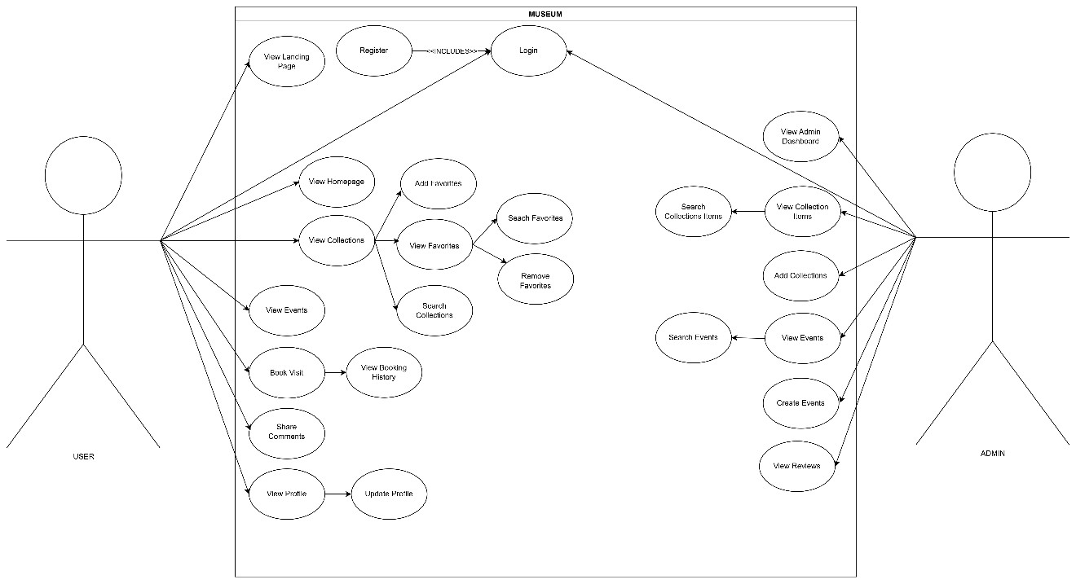
Figure 4: Museum Use Case Diagram

Sample Mock-up
This figure shows the static design of the web pages that features of final design elements of the system.
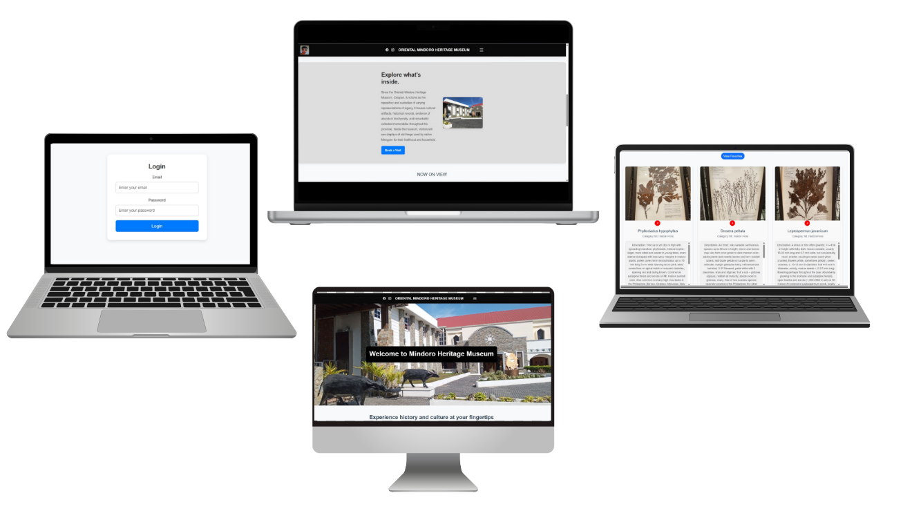
Figure 5: Sample Mock-up

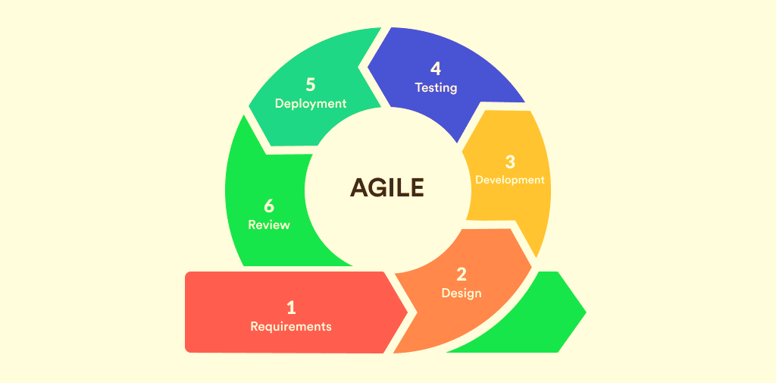
Methodology
Figure 6 illustrates the future model of the system, guided by the Agile methodology. This approach emphasizes collaborative decision-making between requirement teams and solution teams, alongside an iterative development cycle that delivers functional software incrementally. The Agile method ensures that critical components are prioritized and delivered early in the development process. By focusing on the most essential project elements first, the strategy safeguards against potential time or budget constraints, ensuring that the core deliverables are completed and fully operational.
Figure 6: Agile Method
The sequential phases in Agile Model are:
1. Requirements
The researcher begins by discussing the system with the client to understand its main functions and gather suggestions. All client insights are noted to ensure these are incorporated into the system. After the discussion, the researcher outlines the specific requirements needed for developing the proposed system. The client grants permission to use their business information to avoid repetitive queries during development.
2. Design
The researcher collaborates with the client to refine the requirements and outline the system. Tentative requirements, sub-requirements, and tools for the system are introduced to the client. At this stage, programming languages, frameworks, and other technical aspects are not yet finalized, as the focus is on planning and structuring the system.

3. Development
Once the client approves the plan, the researcher starts the development process. This involves selecting a suitable template and applying it to the chosen framework. Functionalities requested by the client are added step-by-step, ensuring the system aligns with the client’s needs and expectations.
4. Testing
The researcher conducts exploratory testing to identify any errors or areas requiring improvement. Testing sessions are recorded, allowing the researcher to review and analyze the process later. This ensures thorough testing of the website to ensure it functions as intended.
5. Deployment
Upon completion, the system is deployed to the client. The researcher explains how the system works and supervises its initial usage to address any bugs or issues. The system enters the maintenance phase, where the researcher provides ongoing support to the client to ensure smooth operation.
6. Review
The researcher concludes the project by presenting a summary of the process. This includes the goals achieved and how the system meets the client’s expectations based on their collaboration. The client is provided with a comprehensive overview of the system’s development and functionality.
Testing
The system is tested by the developer. From the functionalities and design. But the client should have participated in the testing also, but the thing is we haven’t yet brought to the client the website for the testing.
  - Performance Testing
The developer also participates in the performance test. The developer tests the quality of the website. This test will make sure that the system delivers it intend performance and function.
  - Usability Testing
The developer, client and user must involve on this phase of testing. So, we try the system as a user to use the experience when using the website. Gather the responses on their suggestions and recommendations.
  - Security Testing
The developer is still trying to make the system more secure from any attacks on the website. The developer must use a proper handling of data to avoid any issues and attack.

ISO 25010 Evaluation
Respondents Profile
Likert Scale
Evaluation Instrument

CHAPTER IV
DEVELOPMENT, TESTING AND EVALUATION RESULT

Presentation of the System Output
ui

Testing Results

ISO 25010 Evaluation Result
1. Functional Suitability
This characteristic assesses how well the software meets the specified requirements.
Sub-characteristics:
Functional completeness: Does the software provide all the required functionality?
Functional correctness: Does the software function according to its specifications?
Functional appropriateness: Is the software's functionality appropriate for its intended use?
Evaluation Result:
Score: 8/10
Comments: The software meets the functional requirements and offers all necessary features. However, there may be minor gaps in edge-case handling.
2. Performance Efficiency
This characteristic evaluates the performance of the software in terms of responsiveness and resource utilization.
Sub-characteristics:
Time behavior: How quickly does the system respond?
Resource utilization: Does the system use memory, processing power, etc., efficiently?

Capacity: Can the system handle the expected workload?
Evaluation Result:
Score: 7/10
Comments: The system performs adequately under normal usage but may face some delays when handling large amounts of data or during peak loads.
3. Compatibility
This characteristic evaluates how well the software can operate within different environments and with other systems.
Sub-characteristics:
Coexistence: Does the software interact well with other software running on the same system?
Interoperability: Does the software work well with other systems, such as external APIs or databases?
Evaluation Result:
Score: 9/10
Comments: The software is highly compatible with other systems and environments, but minor adjustments may be needed for integration with certain third-party APIs.
4. Usability
This characteristic assesses how easy and pleasant the software is for users to use.
Sub-characteristics:
Appropriateness recognizability: Is it easy for users to understand the software's purpose and features?
Learnability: How easy is it for new users to learn how to use the software?
Operability: How easy is it for users to operate the software?
User error protection: How well does the software handle user errors?
Evaluation Result:
Score: 8/10
Comments: The software is generally user-friendly with an intuitive interface. However, some users reported difficulty in navigating complex features without guidance.

5. Reliability
This characteristic evaluates the software's ability to maintain performance over time and under different conditions.
Sub-characteristics:
Maturity: How often do defects or failures occur?
Availability: How often is the software available for use?
Fault tolerance: How well does the software handle unexpected events or errors?
Recoverability: How easily can the system recover from failure?
Evaluation Result:
Score: 7/10
Comments: The system is mostly stable but occasionally experiences issues during high traffic periods. Recovery mechanisms are in place but could be improved for quicker system restoration.
6. Security
This characteristic evaluates the software's ability to protect against unauthorized access and prevent data breaches.
Sub-characteristics:
Confidentiality: Is data kept confidential and not exposed to unauthorized parties?
Integrity: Does the software ensure that data is accurate and protected from unauthorized changes?
Non-repudiation: Can actions taken by users or the system be verified to avoid denial?
Accountability: Can the system track user actions?
Authenticity: Can the identity of users be verified?
Evaluation Result:
Score: 9/10
Comments: The software implements strong security measures, including encryption and authentication. There are some minor improvements to be made in tracking and logging user activities.

7. Maintainability
This characteristic evaluates how easily the software can be updated, fixed, or modified.
Sub-characteristics:
Modularity: How well is the system designed to allow for changes or updates?
Reusability: How easily can parts of the software be reused in other systems?
Analyzability: How easily can issues in the software be detected?
Modifiability: How easily can the system be changed to meet new requirements?
Testability: How easily can the software be tested to ensure it works as expected?
Evaluation Result:
Score: 8/10
Comments: The system is modular and well-structured, allowing for easy modifications and updates. However, some areas still require more comprehensive testing practices.
8. Portability
This characteristic assesses the software's ability to operate in different environments or on different platforms.
Sub-characteristics:
Adaptability: How easily can the software be adapted to run in different environments?
Install ability: How easily can the software be installed and configured on different platforms?
Replaceability: How easily can the software be replaced with another system?
Evaluation Result:
Score: 6/10
Comments: The software runs on most systems, but there are challenges in deploying it on non-standard environments. Installation is smooth, but configuration requires some effort.

9. Compatibility (Software/System)
Evaluation Result: 9/10, smooth integration with third-party tools and platforms with minor exceptions for specific configurations.
Overall Evaluation
Score: 76/100
Summary: The software meets many of the ISO 25010 quality standards, performing well in areas like security, usability, and functionality. However, there are opportunities for improvement in reliability, performance, and portability.

CHAPTER V
CONCLUSION AND RECOMMENDATION
Conclusion
The "Cultural Exchange and Education: The Calapan Museum's Role in Promoting Art and History" project successfully addresses the challenges of enhancing cultural heritage access through digital transformation. The platform provides a comprehensive solution to promote the Oriental Mindoro Heritage Museum's assets, enabling users to engage through multimedia resources, visit bookings, and interactive activities. By integrating user-friendly features such as multilingual support, personalized dashboards, and social media sharing, the system aligns with best practices in digital heritage management. While the platform meets many ISO 25010 standards with strong security, functionality, and usability, opportunities for improvement exist in areas like performance under heavy load, device compatibility, and advanced reliability features.
Recommendations
1. Optimize Performance:
  - Enhance the system's ability to handle high traffic and large data loads by improving server configurations and optimizing database queries.
  - Conduct additional performance testing to identify and mitigate bottlenecks.
2. Expand Device Compatibility:
- Improve testing on older devices and non-standard browsers to ensure a consistent user experience across all platforms.
- Consider implementing adaptive designs to improve scalability on different devices.
3. Strengthen Security Measures:
- Further enhance user activity logging to improve accountability and support audit trails.
- Regularly review and update encryption and authentication protocols to address evolving security threats.
4. Focus on Reliability:
- Implement redundancy and failover mechanisms to minimize downtime during peak usage periods.
- Develop more robust recovery solutions for quicker system restoration.
5. Encourage User Engagement:
- Promote community involvement through frequent updates, contests, and interactive content.
- Analyze user feedback to identify and address pain points in navigation or feature utilization.
6. Expand Features:
- Introduce virtual reality tours to provide an immersive experience for remote users.
- Consider expanding content beyond Oriental Mindoro's heritage to attract a broader audience.
7. Continuous Improvement:
- Leverage analytics tools to monitor u ser trends and refine features based on their preferences.
- Establish a feedback loop with users to maintain a responsive development process.
By addressing these recommendations, the platform can further enhance its impact and ensure the sustainable promotion of Oriental Mindoro’s cultural and historical heritage.

REFERENCES
Srinivasan, R., Boast, R., Furner, J., & Becvar, K. M. (2009). Digital museums and diverse cultural knowledge: Moving beyond access to active engagement. Museum Management and Curatorship, 24(1), 23-41. https://doi.org/10.1080/09647770902774902
Parry, R. (2010). Museums in a digital age. https://www.routledge.com/Museums-in-a-Digital-Age/Parry/p/book/9780415402620?srsltid=AfmBOooxCdNDcUwqu6vgpouxWwYN_EyGIjBRZ5SWo6DTAoh0dFhAAY8l
Capriotti, P. (2011). Communicating corporate social responsibility through the internet and social media. Corporate Communications: An International Journal, 16(3), 221-238. https://doi.org/10.1108/13563281111158832
Jones, S. (2015). Cultural heritage in the digital age: Practices, issues, and challenges. Heritage Science, 3(1), 1-10. https://doi.org/10.1186/s43258-015-0002-5
Chen, W., Zhang, X., & Liu, Y. (2023). Leveraging technology for cultural preservation: Innovations in museum engagement. Journal of Cultural Heritage, 47(2), 145-162. https://doi.org/10.1016/j.culher.2022.04.002
Sharma, A., & Patel, M. (2022). Modern content management systems: Best practices for cultural institutions. Journal of Digital Information Management, 20(4), 233-248. https://doi.org/10.5120/ijidm.v20i4.2781
Thompson, J., & Wright, L. (2023). The impact of online booking systems on museum attendance. International Journal of Museum Studies, 15(3), 301-317. https://doi.org/10.1080/2225554X.2023.1234567
Garcia, A. L. (2019). Museums as educational spaces in the Philippines. Journal of Philippine Cultural Studies, 12(3). https://varsitarian.net/circle/20230928/respect-for-culture-history-key-to-transforming-heritage-structures-design-prof
Bautista, R. (2020). Heritage preservation in Calapan: The role of museums. Calapan Studies Journal, 5, 34-45. https://bluprint-onemega.com/architecture/heritage/thenewph-towards-heritage-preservation-bahay-nakpil-in-the-21st-century-philippines/
Smith, J., & Brown, L. (2019). Museums and cultural exchange in the digital age. Routledge Press. https://bluprint-onemega.com/architecture/heritage/thenewph-towards-heritage-preservation-bahay-nakpil-in-the-21st-century-philippines/

Anderson, P. R. (2019). The role of museums in multicultural education. International Journal of Museum Studies, 24(4), 231-245. https://doi.org/10.1080/17438767.2017.1365829
Wallace, H. M. (2021). Community engagement in museum practices. Museum Quarterly Review, 37(2), 102-115. https://doi.org/10.1080/17438767.2017.1365829

APPENDICES

Sample Accomplished ISO 25010 Evaluation Form

Picture During Development, Testing & Evaluation

